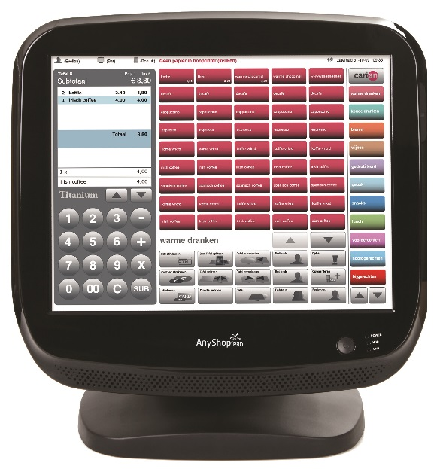 | 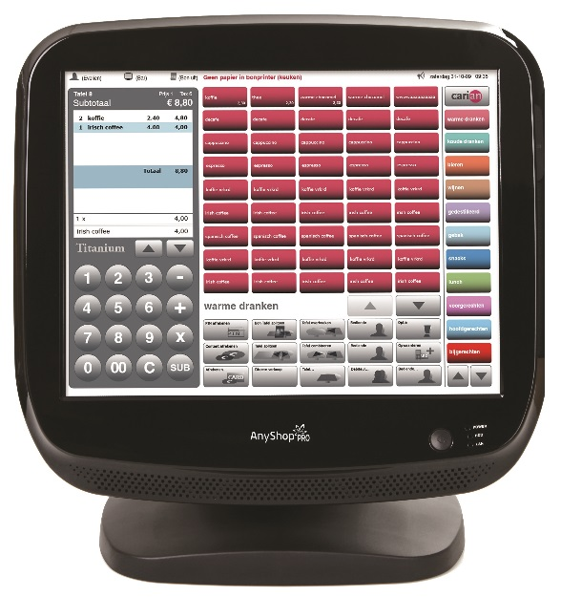 | 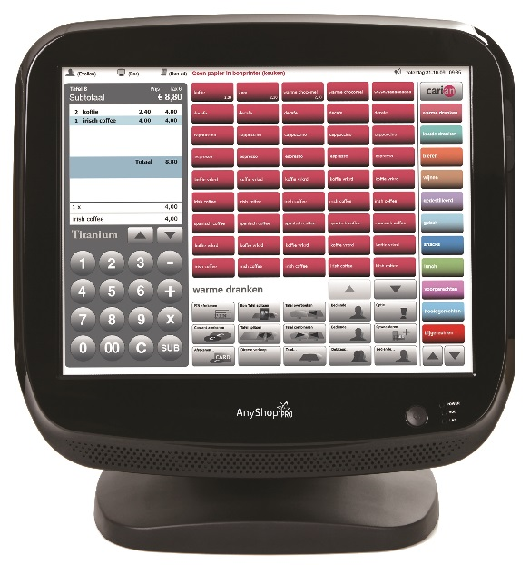 | 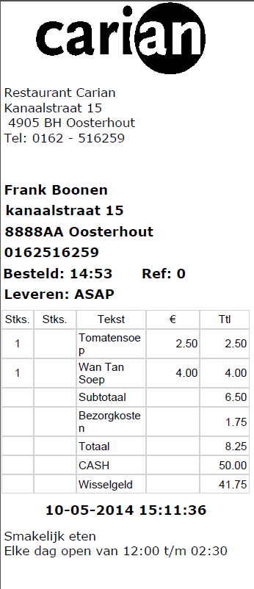
Bundel-1 € 995,00  - 15” Touchterminal  - Windows PosReady 2009  - Carian EasyTouchPos  - 80 MM thermische printer | Bundel-1 € 1.399,00  - 15” Touchterminal  - Windows PosReady 2009  - Carian EasyTouchPos  - 80 MM thermische printer  - 3.5” touch bestelterminal | Bundel-1 € 1.499,00  - 15” Touchterminal  - Windows PosReady 2009  - Carian EasyTouchPos  - 80 MM thermische printer  - 4.3” Touchterminal, met accessoires | Thuisbezorgd.nl printer € 265,00  - 80 MM thermische printer  - Software
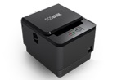 | 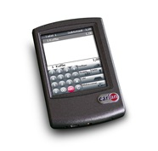 | 